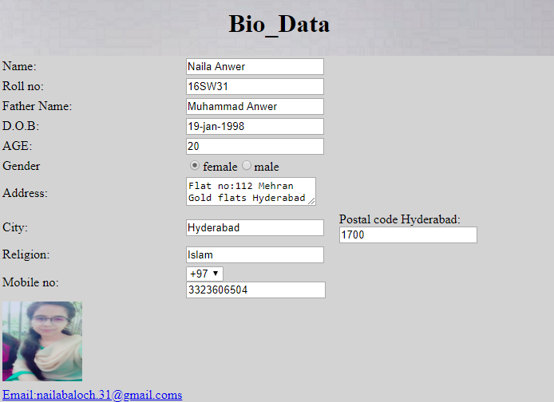

<h1 align="center" >Bio-Data</h1>

<table border="0" width="700" height="400" align="center" bgcolor="lightgray">

<tr><td>Name:</td>

<td><input type="text" value="Naila Anwer"></td>

</tr>

<tr> <td>Roll no:</td>

<td><input type="text" value="16SW31"></td>

</tr>

<tr><td>Father Name:</td>

<td><input type="text" value="Muhammad Anwer"></td>

</tr>

<tr><td>D.O.B:</td>

<td><input type="text" value="19-jan-1998"></td>

</tr>

<tr><td>AGE:</td>

<td><input type="number" value="20"></td>

</tr>

<tr><td>Gender</td>

<td><input type="Radio" name="Gender" value="female" >female<input type="Radio" name="Gender" value="male">male</td> </tr>

<tr><td>Address:</td>

<td><textarea>Flat no:112 Mehran Gold flats Hyderabad</textarea></td></tr>

<tr><td>City:</td>

<td><input type="text" value="Hyderabad"></td>

<td> Postal code Hyderabad:<input type="text" value="1700" ></td></tr>

<tr><td>Religion:</td>

<td><input type="text" value="Islam"></td> </tr>

<tr><td>Mobile no:</td>

<td><select>

<option>+97</option>

<option>+98</option>

<option>+99</option></select>

<input type="phone" value="3323606504"></td> </tr>

<tr><td><img src="C:\Users\CYBER\Desktop\345.jpg" height="100" width="100"></td> </tr>

<tr><td><a href="nailabaloch.31@gmail.com">Email:nailabaloch.31@gmail.coms</a></td> </tr>

</table>